Elemental Engine

SDK

Signature Devices, Inc.’s Elemental Engine is a robust plug-in system that allows for the easy removal and insertion of components into the system. Heavily based on design patterns, this system is robust and solid, due to the ease of using unit testing on the modules. A UML diagram of the main interfaces is here:

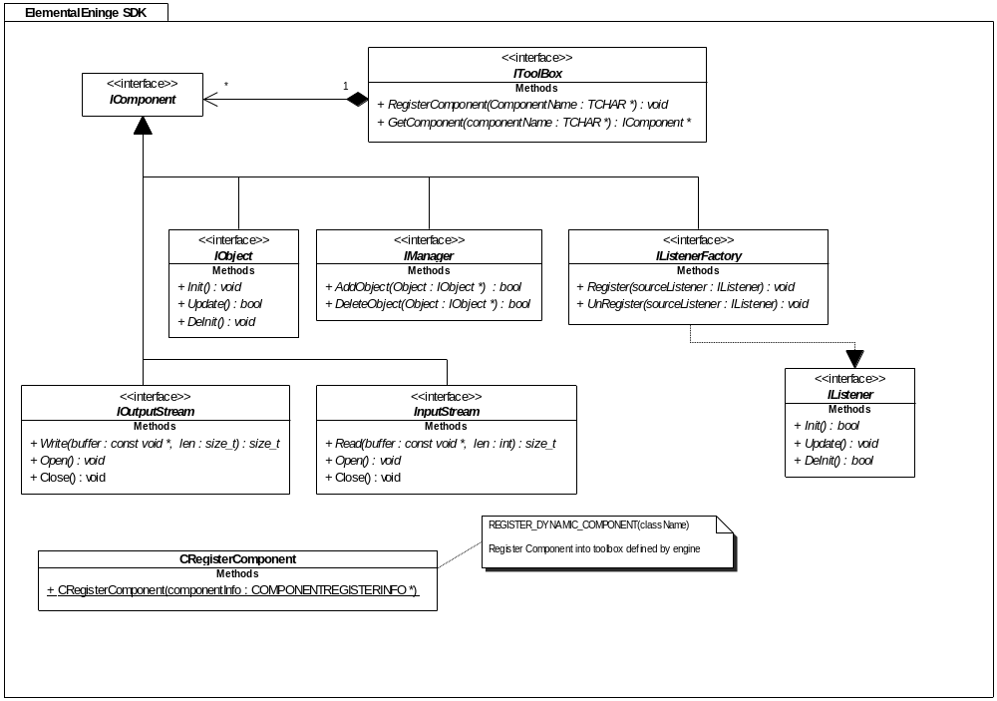

IToolBox

All components of the system are accessed through the IToolBox interface. There is one global function called EngineGetToolBox() that returns a pointer to an IToolbox class. This function is the only export from the DLL (ElementalEngine.dll). Components register themselves in the toolbox in one of two ways.

IComponent

All components of the system are derived from the IComponent interface class. When a implementation class wants to register itself in the toolbox, it can use the macro:

REGISTER_DYNAMIC_COMPONENT(className);

This is a global macro in your concrete class file, i.e. (MyObject.cpp). This class must have a Create function that returns an instance of the MyObject class as a pointer to an IComponent. This class should be declared static in the header file:

static IComponent *Create();

and in the .cpp file the function should look similar to this:

// this constructor adds our object to our manager
CMyObject::CMyObject()
{
IManager *myManager;
IToolBox *toolBox;
toolBox = EngineGetToolBox();

// make sure RTTI information checks that this component is truly
// of type IManager
MyManager = static_cast<IManager *>(toolBox->
GetComponent("MyManager"));

MyManager->AddObject(this);
}

/// Initialization for the Object
/// returns a pointer to an IComponent
IComponent *CMyObject::Create()
{
IObject *self;
// create the object however you must create it
try
{
// try and create an instance
self = new CMyObject;
}
catch(...)
{
return NULL;
}

return self;
}

This encapsulates the objects to take care of themselves.

